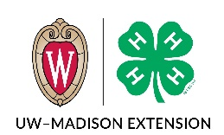
Juneau County 4-H
My 4-H Year in Review

Name ______________________ 4-H Year 20__ to 20__

List offices held | 4-H Club or Group

List 4-H committees served on | List your responsibilities

4-H Club Activities | Briefly Describe Activity | Date
Demonstration/Talk
Conservation/Recycling
Community Service
Club Educational Experience
Club Tour/Picnic
4-H Promotion
Dairy Promotion
Other Activities

County Activities | Briefly Describe Activity | Date
Demonstration/Talk
Textile Arts Revue
Foods Revue
Performing Arts Festival
4-H Camp
County Fundraiser
County Fair
County Project Meetings
Other Activities:

District, State & National | Briefly Describe Activity | Date
Spring Preview Livestock Show
State Fair Exhibitor
State Team
WI Youth Conference
Citizen Washington Focus
National Congress
National Conference
Other Activities:

Please compare your projects
In which project did you learn the most, positive or negative? Why?

Which project was your favorite? Please explain why.

Which project was your least favorite? Please explain why.

