

**Cloverbud**

**4-H**

**A**

**Are**

**You**

**Now**

**Book**

**Record**

**Cloverbud**



**Congratulations & Welcome**

*Cloverbuds are pre-4-H youth, in kindergarten through second grade, who are interested in taking part in the Juneau County 4-H and Youth Program before they can be officially enrolled as a regular 4-H member.*

*Cloverbuds are proud of their enrollment in 4-H. Just see how they smile!* ☺

**Name:**

**4-H Club:**

**Grade in School:**

**4-H Year:**

*This booklet is designed to help you keep track of all things you will do as a 4-H Cloverbud.*

*Picture of You*

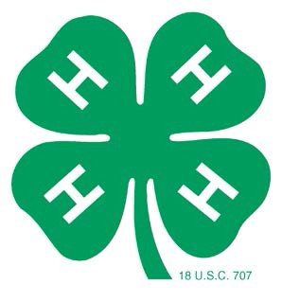

**The**

**4-H**

**Emblem**

**is:**

A green four-leaf clover with

the letter "H" on each leaf is

the emblem.

Each "H" stands

for a part of the pledge -

Head,

Heart,

Hands,

Health

**The**

**4-H**

**Colors**

**Are:**

*Green and White.*

Green symbolizes nature's most common

color.

White symbolizes purity.

**The**

**4-H**

**Motto**

**is:**

*"To Make The Best Better"*

This motto challenges everyone involved in 4-H to do the very best job they can.

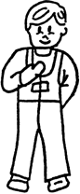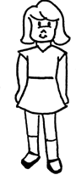

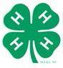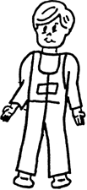

**Flag**

**Pledges**

*The American Flag Pledge:*

“I pledge allegiance to the flag of the

United States of America, and to the republic for which it stands, one nation under God,

indivisible, with liberty and justice for all.”

*(When repeating the pledge, your right hand should be*

*placed over your heart, which is on the left side.)*

*The National 4-H Pledge:*

I Pledge:

**My Head** to clearer thinking

*(Right hand point to forehead)*

**My Heart** to Greater loyalty

**My Hands** to larger service, and

*(Right hand over heart)*

**My Health** to better living for my

club, my community, my country, and my world.

*(Arms slightly bent with palms up)*

*(Arms at sides)*



**Cloverbud**

**Activity**

**Record**

*Check the activities* ***you*** *participated in.*

**Club Activities:**

Club Project Tour

Committee Member

Community Service

Conservation

Dairy Promotion

Demonstration

Health/Safety

Music at club meetings

Oral Report

Picnic/Pot Luck

Recreation

Speech Contest

4-H Week Activities (display/radio)

Other (list)

**County Activities:**

Cloverbud Camp

Cloverbud Sensational Saturday

Communication Arts Festival

County Cloverbud Workshop

Drama Festival

Eat Stand

Fair Booth

Fair Exhibitor

Family Day of Learning

Foods Revue

Music Festival

Other (list):

**Cloverbud**

**Name:**

**Project**

**Record**

**This is my year in Cloverbuds.**

**We had Cloverbud meetings/trips.**

**I went to of these Cloverbud meetings/trips.**

**I went to regular 4-H club meetings.**

**What did you take to**

**the**

**fair?**

***(list)***

**Parent’s Comments:**

**Parent’s Signature:**

**Date:**

**Draw**

**a**

**Picture**

**about**

**4-H**

**Cloverbuds**

**and**

**You!**

**My**

**4-H**

**Cloverbud Story**

*(optional)*

Tell us what you liked about being in 4-H. What was your

favorite thing? What did you do? What would you like to do next year? Include any pictures you have on a separate sheet.

**4-H Cloverbud Supporting Material**

Put clippings and pictures of different 4-H activities you participated in here.