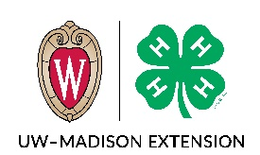
Juneau County 4-H Award Nominations
Fill out one form for each person/entity you are nominating.
Forms are due on October 15.

Category you are nominating for:
Friend of 4-H Award
(Examples: business, service club, organization, corporation)
Youth Volunteer of the Year Award
Adult Volunteer of the Year Award
Does not need to be a certified/enrolled adult 4-H volunteer. Emphasis on adult who donates time on behalf of 4-H.

Nominee (person/entity you are nominating)
Name: ________________________________________________________________________
Street Address: _________________________________________________________________
City:______________________________________ State:________________ Zip:___________
Phone:_________________________________ Email: _________________________________

Nominator (that’s you)

Name: ____________________________________________________________________________
Mailing Address: ____________________________________________________________________
City: ____________________________ State: _______________ Zip:__________________________
Phone:______________________ Email: _________________________________________________

By October 15, completely filled out form (2 pages) should be submitted to:
Juneau County Extension Office
220 E. State Street, Room 104
Mauston WI 53948
Describe the contributions the nominee has made to the Juneau County 4-H Program. Use examples, specific projects, unique ways they’ve served, and number of years. (This information will be used to create a press release and will be read at the Annual 4-H Recognition Program in January).

Signature of person making nomination:

_______________________________________________

